Asphalt Surveillier
An Intelligent road condition monitoring system
Subhankar Bhattacharyya
Dept. of Computer Science and Engineering
Institute of Engineering and Management, Kolkata
(subhankarbhattacharyya1007@gmail.com)
Address : Salt Lake Electronics Complex, Y-12,Gurukul,Street Number 18,EP Block, Sector V, Bidhannagar , Kolkata, West Bengal 700091
Abstract:
The present idea discloses a road condition monitoring system, the method comprising sensor network and image acquisition system with implementation of machine learning algorithms. To provide meaningful input to vehicle control and acquire widely overlapping view a multi-sensor scheme using camera and LiDAR technologies are utilized which yield an ensemble of measurement positions clustered to the road surface obstruction further processed with a state-of-art image classifier. The whole monitoring and reporting system work in a threefold way. Depending on the distance of potential objects or non-uniformity of the road surface the controller either sends warning to the driver or becomes ready to take over the vehicle control by reducing speed or changing gears. Using gyro and accelerometer the measure of vibration caused during the drive will be classified to check the level of discomfort to assist in speed. And finally, to mitigate the accident risk or severe bad condition of the road beyond a certain threshold the controller can stop the vehicle considering propinquity of other vehicles and relative speed difference by IMU and proximity sensor. The proposed architecture model depicts how the sensor technology can be integrated with the transportation infrastructure to achieve a sustainable Intelligent Transportation System and ensure safety and driver assistance by decision making and action taking in addition to alerting driver on the verge of mistake.
Keywords: Drive Assist System, AV, Lidar, Image Processing, Topographical Surveillance, Drive Comfort, Safety, Sensor Network
Reference:
Gao, Hongbo, et al. "Object classification using CNN-based fusion of vision and LIDAR in autonomous vehicle environment." IEEE Transactions on Industrial Informatics 14.9 (2018): 4224-4231. this paper presents an object classification method for vision and lidar fusion of autonomous vehicles in the environment. This method is based on convolutional neural network (CNN) and image up sampling theory. The proposed method can obtain informative feature representation for object classification in autonomous vehicle environment using the integrated vision and lidar data. This method is also adopted to guarantee both object classification accuracy and minimal loss.

Zhao, Junxuan, et al. "Detection and tracking of pedestrians and vehicles using roadside LiDAR sensors." Transportation research part C: emerging technologies 100 (2019): 68-87. LiDAR is a remote sensing technology being used in a wide variety of field these days starting from making precise medical equipment to creating accurate elevation maps using drones. Although in transportation it has only be used to assist some design and planning works which predominantly focuses on autonomous vehicles, regardless of its tracking potential. This paper explores some fundamental concepts, solution algorithms, and guidance related to using LiDAR sensor-based infrastructure. Based on LiDAR data collected within the field, investigations were conducted within the order of background filtering, object clustering, pedestrian and vehicle classification, and tracking. The results of the analysis include accurate and real-time information of the presence, position, velocity, and direction of pedestrians and vehicles

Fu, Rui, Mingfang Zhang, and Chang Wang. "Behaviour analysis of distant vehicles using LIDAR point cloud." Cluster Computing 22.4 (2019): 8613-8622.In the autonomous vehicle field, vehicle behaviour analysis is an essential issue. Considering the fact that most vehicles use dense point cloud from 3D LiDAR, ignoring the potential risk caused by distant vehicles. This paper explores the complementary property of sparse point cloud cluster and proposes a behaviour analysis method for distant vehicles through pose estimation and tracking. A multi-frame fitting is conducted using a convolution optimization technique to estimate vehicle pose at each frame effectively. By interacting multiple models, a framework is built which combines the constant velocity model and variable-axis Ackerman steered model to get the motion characteristics of distant vehicles. Eventually, an unknown vehicle behaviour is learned using the variation of track trajectories supported on the sequence of position and velocity information within a given time window.

Weissman, H. M., Ganchrow, E., & Mimran, A. (2020). U.S. Patent Application No. 16/039,686. In this paper a technique for operating a navigation system is provided. In this a first localization solution of the location of the vehicle in a navigable environment using radar transceiver of the navigation system is used. A second localization solution of the vehicle in a navigable environment using LiDAR transceiver, camera or both are used. Selecting a localization solution from the first and second localization solutions based on whether an accuracy of the first localization exceeds an accuracy of the second localization solution, and utilizing the selected vehicle localization solution for navigation of the vehicle through the navigable environment.

1 Introduction
Autonomous Drive (AV) and drive assist systems promises a safe, comfortable and efficient driving experience with decreased chances of road accidents. Substandard road conditions, inefficient transport infrastructure, potholes, deconstructed asphalts, poorly coalesced speed breakers and down-and-out drainage system on the roads are a cause of increasing accidents, driving discomfort, traffic jam are also one of the key roadblocks for implementing AVs in India. Humans are subject to human error and machines are subject to mechanical errors. We as engineers always attempt to balance between the two to urge the simplest optimal result. In countries like India, roads aren't uniform and within the desired condition and typically contains pot holes which reduces driver experience and luxury. Driving Autonomous Vehicles (AVs) in such road conditions may be a true deep learning challenge. The country, forecast to soon be the world’s third largest auto market, is loath to be left behind whilst its chaotic roads and regulations create unique hurdles. this suggests so as to put AVs in Indian roads one has to account for pedestrians darting through traffic at will, multiple lanes that merge without warning, poor signage and stray cattle lingering on the roadside.
As said by Roshy John, a 17-year veteran within the field of robotics heading Asia’s largest IT services provider Tata Consultancy Services Ltd. “Driverless cars for public use are a minimum of 10 years away”. He said the country’s challenges could provide the ultimate proving ground. “If it can work in India, it can work anywhere within the world.”. Having said that it doesn’t mean we stop looking for other alternatives till that day comes. A decade long is quite a long time to wait for something to happen. Hence a solution to this is the main motivation of this paper.
Firstly, in order to solve problems like these we need to realize to make our idea as economical as possible because we are talking about a country where economical tension is going to be a prolonged factor for a long long time so we need to look at the main basic problems and try to solve them as traditionally as possible and then build our way to the top. In order to make the Indian masses get accustomed with AVs we first need to introduce semi-AVs that can use sensors with economical ways of implementation.
One such way that we discuss in this context is the use of LiDAR images, motion and proximity sensors to alert the drivers of impending dangers in the road instead of expensive techniques of camera image processing and deep learning.
2 Problem Description
A. Problem statement
In countries like India, roads are not uniform and in the desired condition and usually consist of pot holes which reduces driver experience and comfort. Existing electronics like IMU, GPS and ADAS systems may not be completely adopted to conditions like Indian roads where constructions and roads change frequently and using the solutions might be costly for smaller cars. even if the principles are changed to permit driverless vehicles, integrating them into city traffic will remain especially complicated in India. Roads can vary between modern highways and dirt tracks, with erratic street signage, a good sort of vehicles and therefore the occasional elephant or camel. Take for instance the always present, three wheeled rickshaws are rigged in many ways by its drivers which sensors struggle to spot its form, hence machine learning algorithms face difficulty.
So how do we use cost effective solutions? Top Priority Issues out of above-mentioned issues Desired Outcome Innovative solutions determining and classifying road scenarios for adaptive driving and comfort
B. Data
Apart from the anarchy of its streets, developers in India have also given up a head start to global giants who are pouring billions into developing platforms. Companies like Ford Motor Co., Alphabet Inc., Tesla Inc., Uber Technologies Inc., and Baidu Inc have all invested, no one has actually developed a roadworthy autonomous solution. In the outskirts of Bangalore there is a secret testing track where Tata conglomerate is recreating the jumble of Indian roads to develop an autonomous driving system.
Autonomous driving or self-driving vehicle may be a commonly used term lately and has become an integral a part of the regular road-going cars in how or the opposite. While by definition, an autonomous car may be a vehicle that drives itself with none human intervention, there’s actually far more to the autonomous vehicles rather than just the self-driving component. As autonomous driving depends on infrastructure and it is also capital intensive, autonomous technology is used by automakers thus making cars safer. Also, autonomous car projects are largely contained during a closed environment during the testing phase, barring a couple of places like California, thanks to the security hazards and ‘Liability Clause’. There’s a low-down on autonomous vehicles, levels of autonomous driving and the safety parameter of self-driving cars.
Although nobody within the world wants to urge involved in an accident, the sad reality is, if you're driving a vehicle, you'll become involved in an accident, no matter how small it is. Now when an accident occurs, there usually is a guilty driver behind it. But what happens in the case of an autonomous car? Who will be held responsible in case of an accident as there’s no one driving the car? This troubling question is looming over the governments and administrations from across the globe and nobody is able to find a global solution as of now. This scenario in autonomous vehicles is named the ‘Liability Clause’. Society of Automotive Engineers has defined autonomous driving at various levels from 0 to 5, depending upon the relation between the vehicle and driver. Here’s a brief explanation of each Level-
Level 0: the driver has the full control but the automated system can issue warnings and momentarily intervene (e.g. Lane driving system in Volvo XC60).
Level 1: the driver as well as the automated system has the control over the vehicle. E.g. - Adaptive Cruise Control (ACC) where driver controls steering and automated system controls speed. Lane Keep Assist in which the steering can automatically bring the car back in the lane when it leaves the lane without driver’s notice. The driver can full control of the vehicle any time.
Level 2: full control of the vehicle is taken by the automated system. The driver can intervene if the system fails to respond properly. It is called the “hands off” form of driving but contact between hand and wheel is mandatory during SAE 2 driving.
Level 3: the driver can turn the attention away from the vehicle and let it drive by itself, while doing personal tasks. Any emergency situation can be addressed by the vehicle itself but the driver must be prepared to intervene when instructed by the vehicle. 2018 Audi A8 Sedan is the first commercial car that has level 3 in self-driving.
Level 4: driver has to be alert for any possible situation in the level 3, but no driver attention is required here in this level. The driver can go to sleep or even leave his/her seat.
Level 5: This is the final level and does not need any human intervention. In fact, is has no steering for control. Ex-robotic taxi.
Countries like the U.S. are advanced in the development of self-driving technologies. Parts of California actually promote testing autonomous cars. India, however, is yet to experience the technology in its purest form It is getting limited autonomous tech and that too in costly cars. Players like Tesla, have mastered this technology are not selling their vehicles in India.
3. Solution
The proposed idea is to make total and utmost use of mainly three basic sensors i.e., proximity sensor, IMU (gyro) and LiDAR sensor. In order to realize the complete function about each sensor let’s first get familiarized with each sensor individually.
A proximity sensor detects the presence of nearby objects with none physical contact. A proximity sensor usually emits an electromagnetic field or a beam of electromagnetic waves and appears for changes within the field or return signal. The object being sensed is usually mentioned because the proximity sensor's target. Different proximity sensor targets demand different sensors. E.g.- a capacitive proximity sensor or photoelectric sensor is suitable for a plastic target; an inductive proximity sensor always requires a metal target. Due to the absence of mechanical parts and lack of physical contact between the sensor Proximity sensors have high reliability and long functional life and therefore the sensed object. Proximity sensors also are utilized in machine vibration monitoring live variation in distance between a shaft and its support bearing. Hence can very well be designed to keep in check for collision with nearby cars as well as the level of vibration produced by the car while driving through bumpy roads.
An inertial measurement unit (IMU) measures and reports a body's specific force, angular rate, and sometimes even the orientation of the body, employing a combination of accelerometers, gyroscopes, and sometimes magnetometers. Recent developments leave the assembly of IMU-enabled GPS devices. An IMU allows a GPS receiver to figure when GPS-signals are unavailable, like in tunnels, inside buildings, or when electronic interference is present. Hence making it a very good companion in Indian roads where proper network and correct working of GPS cannot be expected most of the time.
LIDAR - or Light Detection and Ranging - employs UV, visible or near infrared light to image objects and then maps their physical features. Several measurements are taken in quick succession to yield a posh map of the surface at high resolution. LIDAR measures the space to a target using active sensors which emit an energy source for illumination, rather than counting on sunlight. When the sunshine hits the target object, it's reflected back to a sensor which measures the time taken for the beat to recover from the target. The distance to the object is deduced by using the speed of light to calculate the distance travelled accurately. The result's precise three-dimensional information about the target object and its surface characteristics. The main advantage of LiDAR’s over conventional car cameras is that it is independent of the quantity of light present in its surroundings.
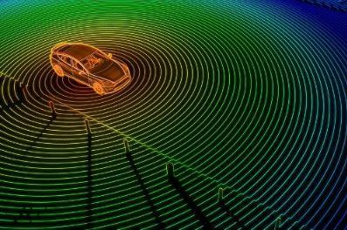
Fig.1 LiDAR sensing surroundings
Together with these three sensors and a camera we can gather information like speed of the car , proximity of the car in accordance to other objects in its surroundings, presence of any uneven terrain in proximity to the car, relative speed of neighbouring vehicles and it’s trajectory, vibrations produced by the car while driving etc. and use these gathered information to our advantage(as in fig 1 and fig 2). It is basically a Level 1 semi-autonomous arrangement.
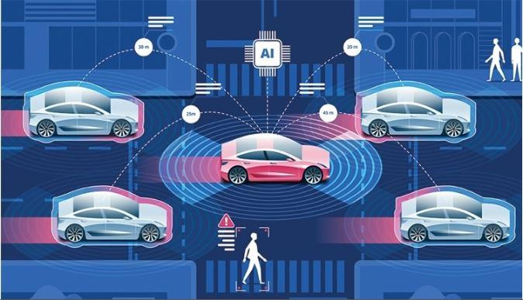
Fig.2 Proximity sensors covering up the blind spots created by LiDAR imaging depicted by the continuous circular region while the red shadow depicts the relative speed of the surrounding vehicles
Firstly, a 360-degree LiDAR sensing camera continuously gathers information about the area surrounding the vehicle and tell the system about any potholes or other obstruction in its trajectory which sometimes the camera can misjudge as shadows in the road. IMU informs the system about its current trajectory and speed which will help the system to take decision on whether to take partial control over the car or just alert the driver. Reading from proximity sensor and a small camera at the rear end of the car will help the driver while parking. Proximity sensors at the surface of the car will help covering up the blind spots created by the lidar imaging thus increasing the sensitivity and precision of the car.

Algorithm: Framework of curb detection.
Require:
Point clouds collected by LiDAR;
Ensure:
Step 1: Given input point cloud, select interested area;
Step 2: Calculate vector difference of adjacent points;
Step 3: Select curb-like points and filter out noises;
Step 4: Separate higher obstacles by comparing the height with a threshold;
Step 5: return Curb points.
After gathering all this information, the system can basically act in 3 modes. They are as follows:
MODE A: When the system detects potholes or irregularities or obstruction on the road up ahead in the trajectory or maybe a traffic signal it then alerts the driver with a constant beeping noise describing the inattentive driver of the impending danger. It can even alert the driver of chances of rare ending someone while parking or while moving through small dingy roads which are quiet a common feature of Indian roads. The system can also keep track of cars running Infront of or back of the car and calculate the relative speeds to avoid any illegal overtaking and rash driving from the driver’s end. Images collected from the camera informs the driver continuously of traffic signals over a small display screen and also helps keep track of any road landform changes and construction sites and thus updating the map GPS systems continuously.
MODE B: What happens when the car suddenly comes in close proximity to some other vehicle or animal on the road such that informing the driver about it is no longer a valid option for the system. The system then takes partial control over the vehicle controlling its speed while the driver can still steer out of it comfortably thus reducing the pressure on driver to control speed and direction and making some misjudgements and ultimately hitting the obstruction by limiting the controls provided to the driver.
In case the system detects a certain depression or elevation or any other irregularities in terrain on its trajectory it then again gains partial control over the speed of the vehicle for the sake of adaptive driving and comfort of suspension for the people sitting inside the terrain. In case it detects a traffic signal or a sharp turn ahead of it, it automatically turns the back light on and slows down the vehicle to a level so that the driver can comfortably make the turn. Thus, abiding and making sure that the driver follows proper traffic rules while driving.
MODE C: This is where things get more interesting. What happens when a vehicle or a commoner suddenly approaches the vehicle from the other side of the road or cattle suddenly comes by and stops at the middle of the road or what happens or while changing lanes u suddenly encounter a vehicle coming from the opposite side. The System then momentarily takes entire control of the vehicle till the time the danger is totally out of the way because a system’s reaction time is far more superior to an individual’s reaction time in these kinds of situations. For the first case presented the system either momentarily stops the vehicle depending on the speed and distance of the vehicles approaching the driver from the rear end or honks and tries to take a different trajectory in order to avoid any collision. For the second case if any living obstruction comes at the middle of the road the system has to stop immediately and effectively and honk continuously till the obstruction is cleared.
These are mainly the three step control process that is going to take place in such semi-autonomous vehicles which although is nothing compared to what autonomous vehicles can provide but in the roads of India it is a really effective and economical way to deal with accidents and make driver’s journey as convenient and comfortable as possible. It will not only assist the driver with driving but also pave way for the advent of AVs in India because the main problem in India is the tendency of the drivers to not follow the traffic rules while driving and breaking the rules as and when necessary. Making these types of semi-AV systems compulsory in every vehicle will not only enforce the drivers to abide by the traffic rules but also highly decrease the amount of road accidents in India exponentially.
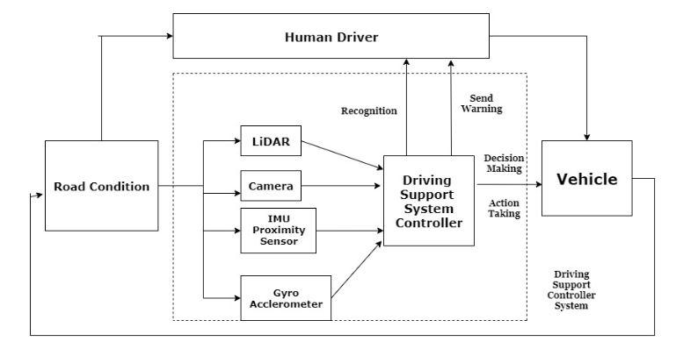
Fig.3 A simple flowchart depicting the control system
From fig 3, LiDAR sensor mainly captures a 360 degree image of the surrounding area of a certain field radius and transforms the whole image into a visible spectrum field rating where closer areas are depicted with high wavelength colours(such as red) and further areas covered with lower wavelength colours( such as blue or violet) as shown in the given diagram. Thus, a certain blue or dark area on a red spot will indicate a depression and a certain bright red spot on a fairly blue area will indicate a sudden elevation in the trajectory path which will indicate a certain anomaly in the road and the system gets ready to take action. When a car or a vehicle suddenly comes to close to the driver’s vehicle the proximity sensors generate high frequency signals to alert the system of an incoming danger and the system then analyses the proximity pattern of the certain vehicle and drives out of the way or if there is no way out then calculates the damage count on impact and deploys the safety bag accordingly to make the driver secure. The image sensor keep a look out for both front and back of the car for any possible collision and makes sure that the driver doesn’t break any traffic law while driving and keeping the judgement of driver to change lanes in mind it makes sure and provide information to the driver about the presence of vehicles while lane shifting and overtaking. Fig 4 is a general undertaking of sensor network.
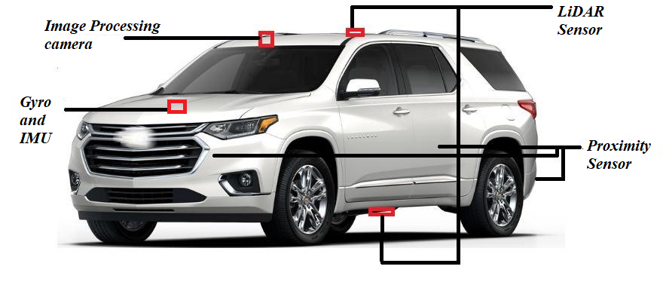
Fig.4 Sensor network diagram
4. Result Analysis
After putting real life test and collecting data on pedestrians, trees, traffic signs, light poles etc. to make recognition data of different surroundings and environment we gather the data.
After recognizing and tracking pedestrians around the autonomous vehicle, pedestrian position are then compared with curb positions (the calculation of curb position will be presented in the next section), alarms will be generated if either of the following two conditions are satisfied:
- Pedestrian is on the road in front of autonomous vehicle
- Pedestrian is tending to cross the road.
The second condition can be monitored by checking the positions and velocity directions of pedestrians who are close to curbs. In addition, we track all pedestrian candidates by applying nearest neighbour algorithm, the same pedestrian candidate is assigned an invariant ID, this ID exists until the candidate is lost. The recognized pedestrians are divided into two categories by comparing their positions with curbs’, i.e., on road and outside of road. If a candidate is classified to be a pedestrian in frame j, it will be classified to be pedestrian in the following frames j + 1, j + 2, . . . as long as the tracking is not interrupted. The reason of this is that most false positives are caused by objects outside of road due to their similar shapes to pedestrians, while on-road false negative needs to be avoided as much as possible, however, when on-road pedestrians become too close or too far from autonomous vehicle, only a few laser beams are irradiated on pedestrian, this may cause missing recognition of pedestrians (i.e., false negative), this is very dangerous for autonomous vehicles. By the aid of tracking results and curb detection results, the true positive rate has been improved a lot.
The quantitative evaluation is carried out to verify the effectiveness of the pedestrian recognition and tracking algorithm proposed in this paper. 3D range data is collected by Velodyne 64 (mounted on top of an autonomous vehicle/LiDAR) in real urban environment, shows the autonomous vehicle equipped with Velodyne 64, Velodyne 16, IMU and Encoder etc. Two kinds of scenarios are chosen for the experiment, one scenario is that the autonomous vehicle is parked by the side of a crowded road, pedestrians are walking around, including those who are carrying briefcases or backpacks, walking side by side etc. Another scenario is that the autonomous vehicle is moving on the road, different pedestrians are walking/waiting on the sidewalk, or crossing the road in front of the autonomous vehicle.
TABLE 1:
Condition of the scenario when autonomous vehicle is parked by the side of the road.
Description Total N pos. N neg.
Training data 2770 608 2162
Evaluation data 10050 1380 8670

TABLE 2:
Condition of the scenario when autonomous vehicle is moving on the road.
Description Total N pos. N neg.
Training data 2282 328 1954
Evaluation data 6340 1020 5320
Tables 1 and 2 show conditions for training and evaluating in these two scenarios, respectively. Given Figs. show the corresponding ROC (receiver operating characteristic) curves, where the vertical and horizontal axes represent true positive rate and false positive rate, respectively.
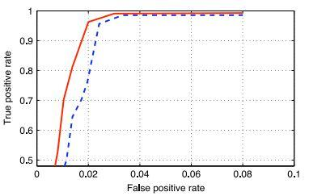
Fig.5 Recognition performance when autonomous vehicle is parked by the side of road. Dashed line is the recognition result of classifier trained by SVM, while solid line is the result improved by tracking results.
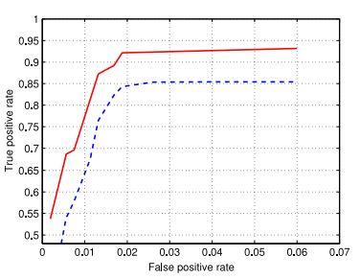
Fig.6 Recognition performance when autonomous vehicle is moving on road. Dashed line is the recognition result of classifier trained by SVM, while solid line is the result improved by tracking results.
The dashed line is recognition result of classifier trained by SVM, while solid line is the result improved by tracking results. It can be seen that true positive rate is increased approximately 0.15 and 0.1 at the point where false positive rate is 0.02 for these two scenarios, respectively as shown in fig. 5 and fig. 6.
5. Conclusion
From fig 7 the above statistical chart, we can see that more and more people are concerned with trusting autonomous technology and its concepts. In order to get the masses interested and make them comfortable adopting AVs we need to first let them experience the lesser risky version(according to their thought process) of such vehicles so that they won’t have to lose control over their vehicle at any time and anything that happens or may happen will be the sole responsibility of the individual driver driving the vehicle. Although with the advent of new generation it is expected that people will be having a more open view to these kind of safety vehicles and have a more day-to-day disciplined life while on the road. While AVs create excitement in masses semi-AVs provide a more general and logical solution when it comes to Indian roads or roads of other countries where they are still in a developing stage and can’t afford to buy such expensive AVs.
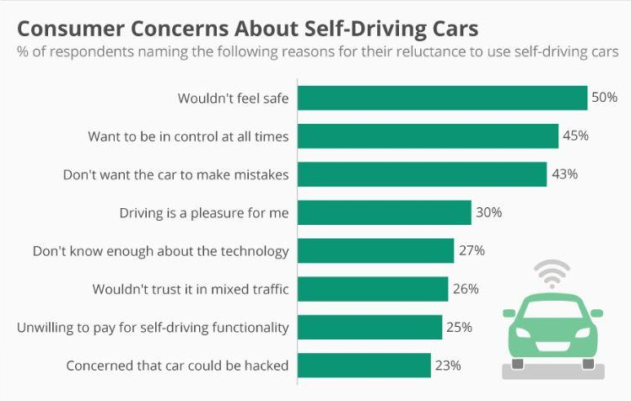
Fig.7 Consumer concern statistics
If ride-on-demand services such as Uber & Ola have made a revolution in the idea of conveyance, self-driving vehicles are going to be the next renaissance shaking up the whole transportation industry. This new idea is on its way to become a multi trillion-dollar business — bigger than Amazon and Walmart combined. According to the planet Economic Forum the big leap within the auto industry will be delivering $3.1 trillion annually by reducing number of crashes, need for emergency services, saving man-hours, cost of car ownership & also indirect savings from shorter commutes and fewer carbon emissions. On top of that, there are endless design possibilities, once you eliminate the necessity for a wheel and a driver. Cars might be compact and egg-shaped or box-like mobile homes which will offer far more than mobility. Drastically different car design means drastically different roadways. The road itself could suggest a faster and safer routes and smart devices which will be embedded in vehicles and infrastructure — would communicate on the fly to accommodate traffic.

